**Hebi X5-9**

**Reference website:** <http://docs.hebi.us/core_concepts.html>

# Connecting the HEBI X5-9 to the computer

Use the following Static ip and Subnet id values.

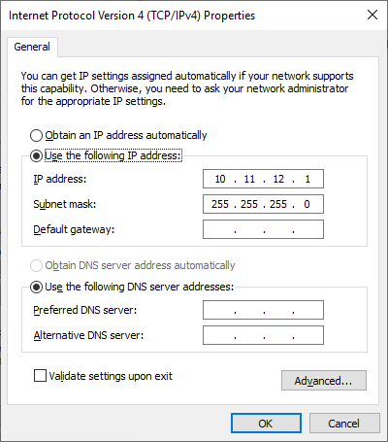

## 

## **In case of requiring reset:**

Press the reset button.

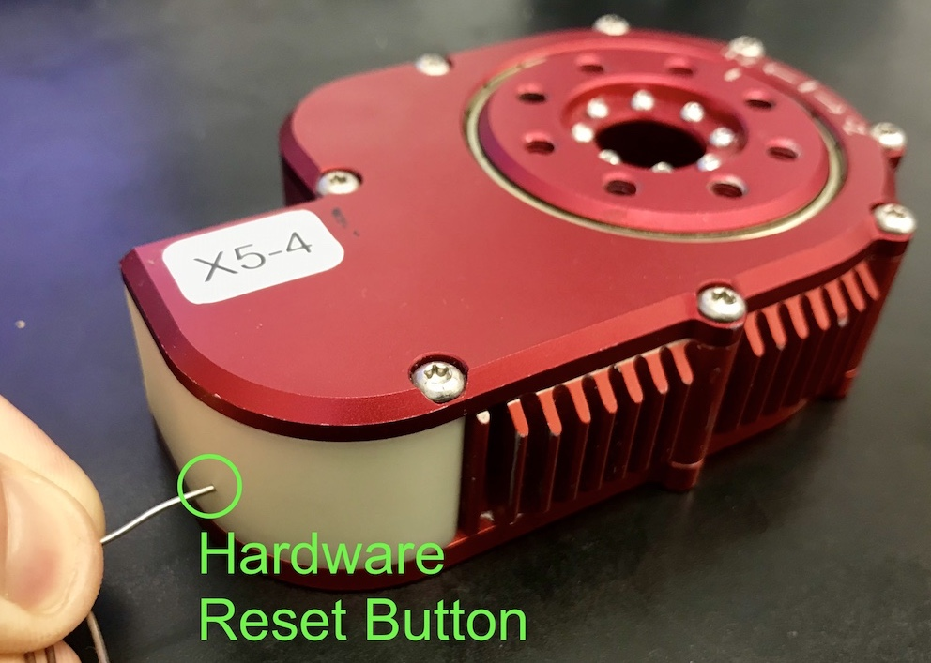 image credits:<http://docs.hebi.us/core_concepts.html>

Press and hold the reset button till the LED colour changes from solid green to blinking green.

Type in the same static ip address



* **HEBI website has a mistake** in the IP address after reset, it mentions 10.11.12.13 as the static ip after a reset but **it is actually 10.11.12.1**
* The **subnet mask 255.255.255.0** on the website is correctly mentioned.

# 

# Using the Scope program

Open Scope program (Download: <http://docs.hebi.us/tools.html#scope-gui>)

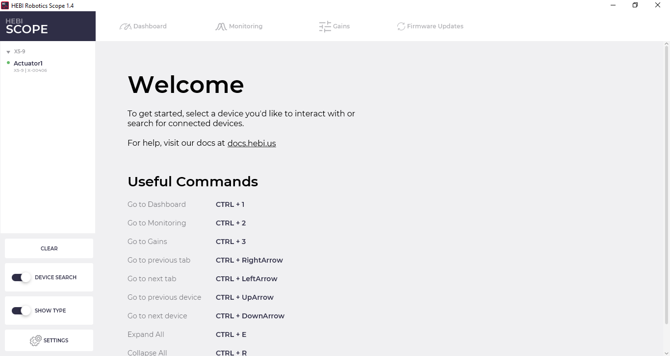

1. Click on Actuator1 on the left hand side (or whatever name the HEBI actuator has).
2. Click on gains, on the top bar (second from the right)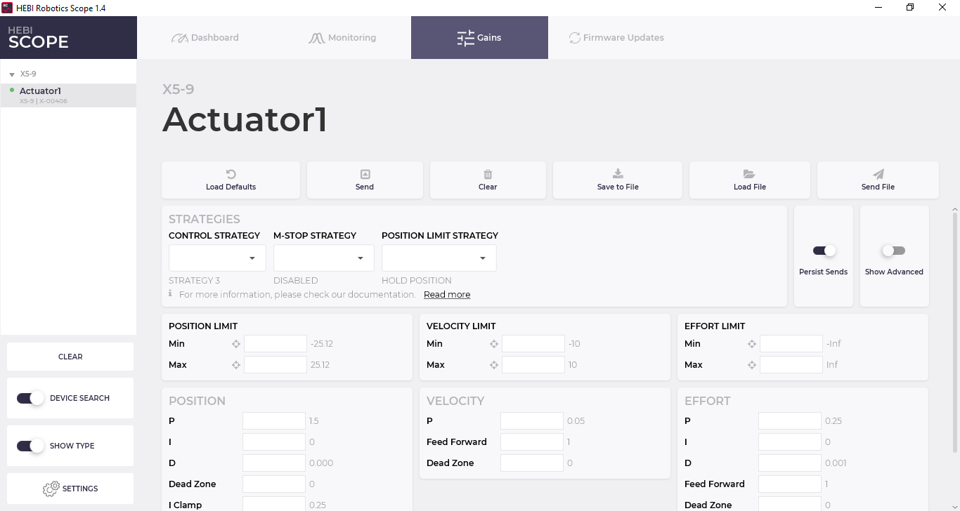
3. If the **M-Stop strategy** (red circle) is in **MOTOR Hold** mode, then change it to **DISABLED**  
   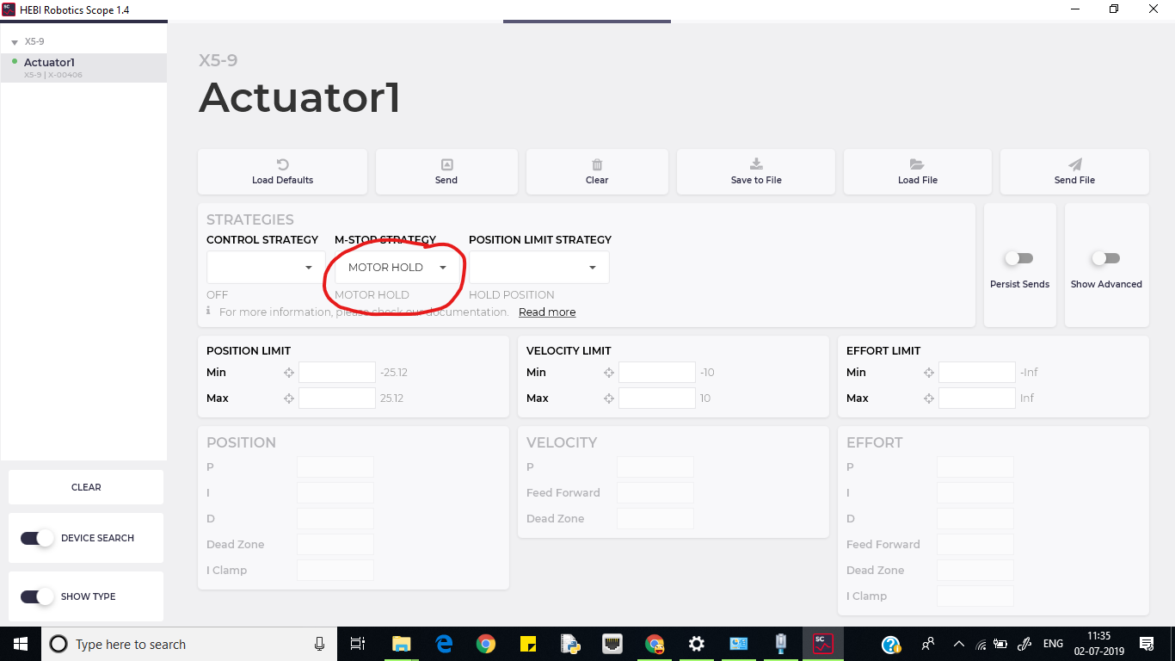  
   Click on Send  
   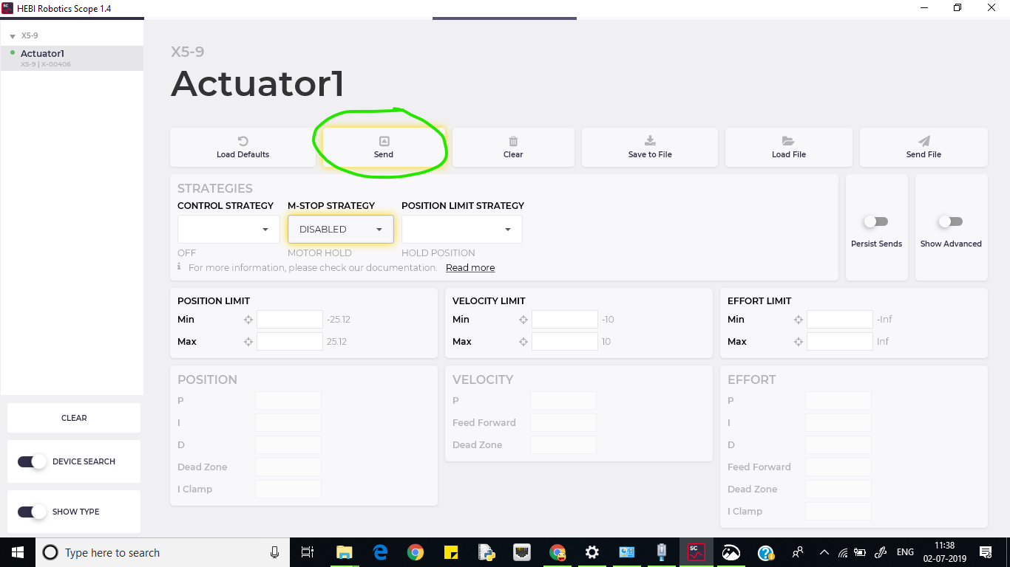
4. Click on **PERSIST Sends** on the left side to ensure that M-Stop strategy remains disabled each time the actuator is switched on.  
   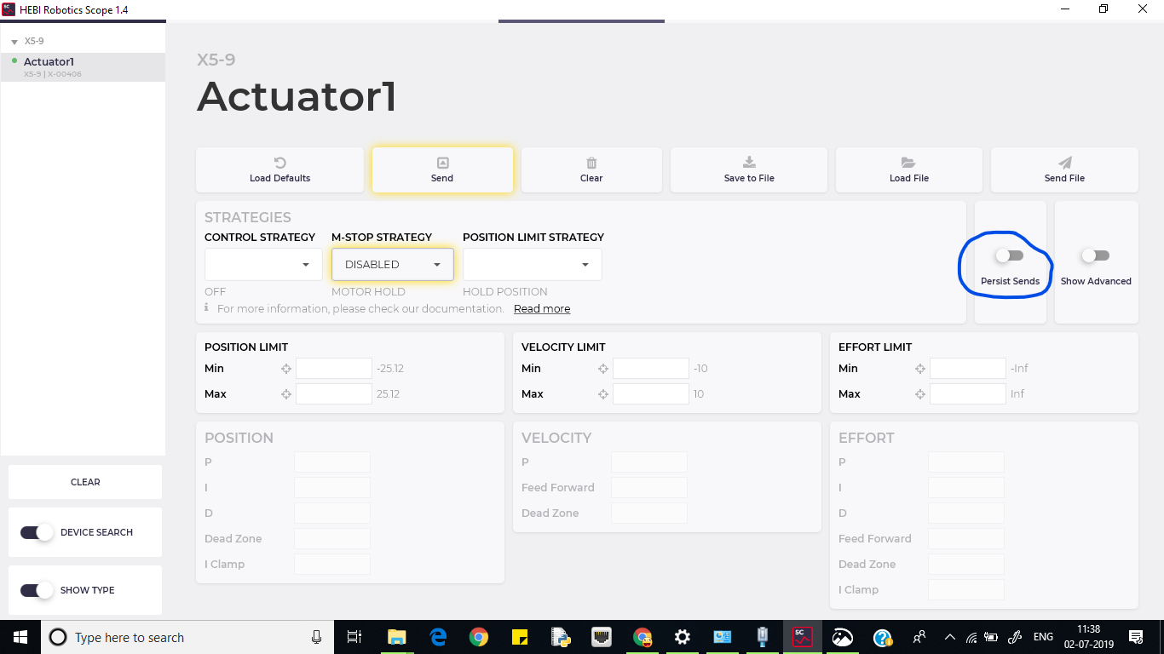  
   Going back to the Dashboard will now show NotTriggered  
   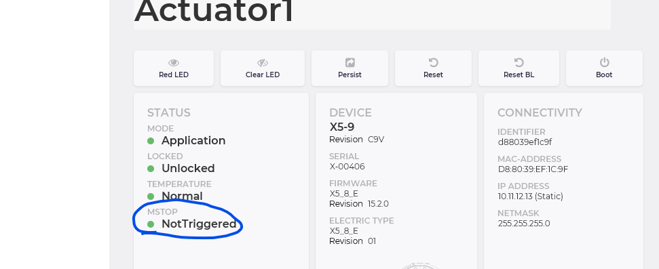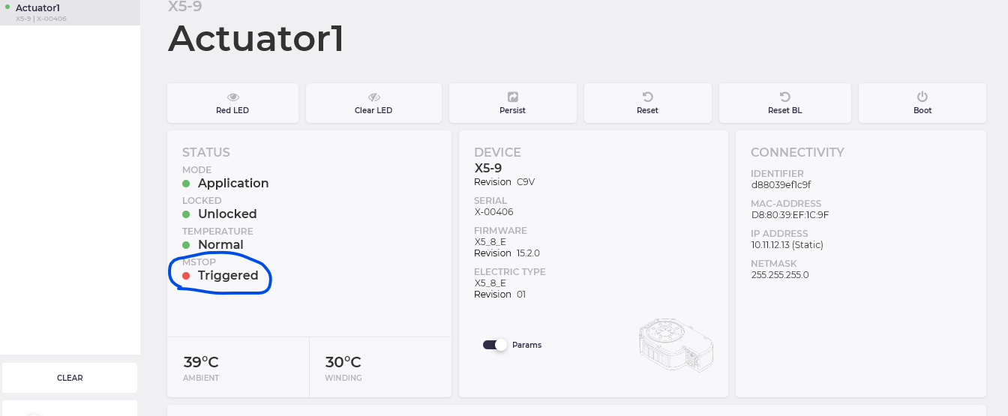  
   If you see (Red) Triggered then you have to go to Gains page and change the M-Stop to disabled and ensure that persist is on. After clicking send, the status on Dashboard will become (green) NotTriggered.

# 

# Python for HEBI

Link: <http://docs.hebi.us/tools.html#python-api>  
  
Python documentation on HEBI website is very good. Refer to it.

Remember to change the Module Name to Actuator1 and Family name as X5-9 in all python codes (or whatever name you gave the actuator)  
